**Issue:**

**-Fix name:** Keyboard Shortcut for reloading plugins

**-Number on github:** #19102

**-type:** Feature Request

**-steps to reproduce (if applicable):**

1. Open Godot Editor
2. Create a new project
3. On the navigation bar, select project settings
4. Navigate within to the project settings to plugins
5. Download a plugin
6. Press F8 and nothings occurs

**-steps to find bug (or where code should go):**

1. Make a directory-wide search on Godot for plugin and shortcuts
2. From the search 6 files appeared: editor_node.cpp, editor_node.h, editor_plugin_settings.cpp, editor_plugin_setting.h, project_settings_editor.cpp and project_settings_editor.h
3. Find that shortcuts are defined in the editor_node.cpp and editor_node.h
4. Find that plugins are declared in editor_plugin_settings.cpp and editor_plugin_settings.h
5. Find that plugin functionalities are defined in the project_settings_editor.cpp and project_settings_editor.h

**-EIS: 3** files

**-AIS (number of files and list): 6** files were modified in total

**-estimated and actual times to fix:** we expected the implementation of the feature to take 25 hours. However, it took about 16 hours.

**-before/after screenshots of code (diff from github):**

Since it is a feature request, there are no before screenshots

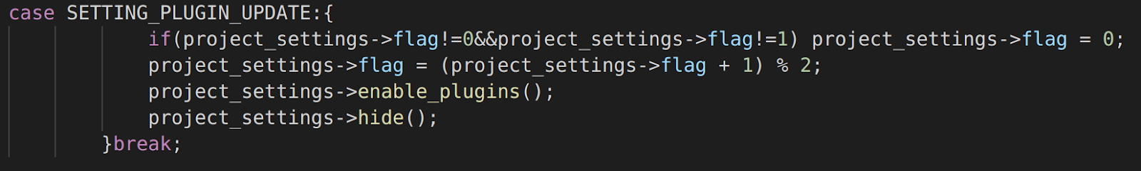

*Fig 1. Screenshot of the added code to editor/editor_node.cpp from line 1736*

https://lh4.googleusercontent.com/5ZtS1LKc4ya1Fwf8YjyBb4FMrtDfWdVc39AOFC1lC6H1iodb3KnaAmAKJNel6K2TYOdbGZ86rrI437bt_hjDAfYCDORI4da2l2ZjEflZDu6l-eaXYh_n7ZeYPvJZMcYjKX4r6cPs

*Fig 2. Screenshot of the added code to editor/editor_node.cpp at line 5201*

*https://lh6.googleusercontent.com/AOm6qm5jdwyTq9ZtWYDR7C13Aa05SGGJz4KtZ0pRxnggvktIg4O7aIKfEMXsgsQutxiPaeM3-o_jmyuJ9_nxXplUEYUNNeqmdI9DkMiXkx9YUqcWRf7pBKY41aBhQ8QNOAgXiPwC*

*Fig 3. Screenshot of added code to editor/editor_node.h at line 123*

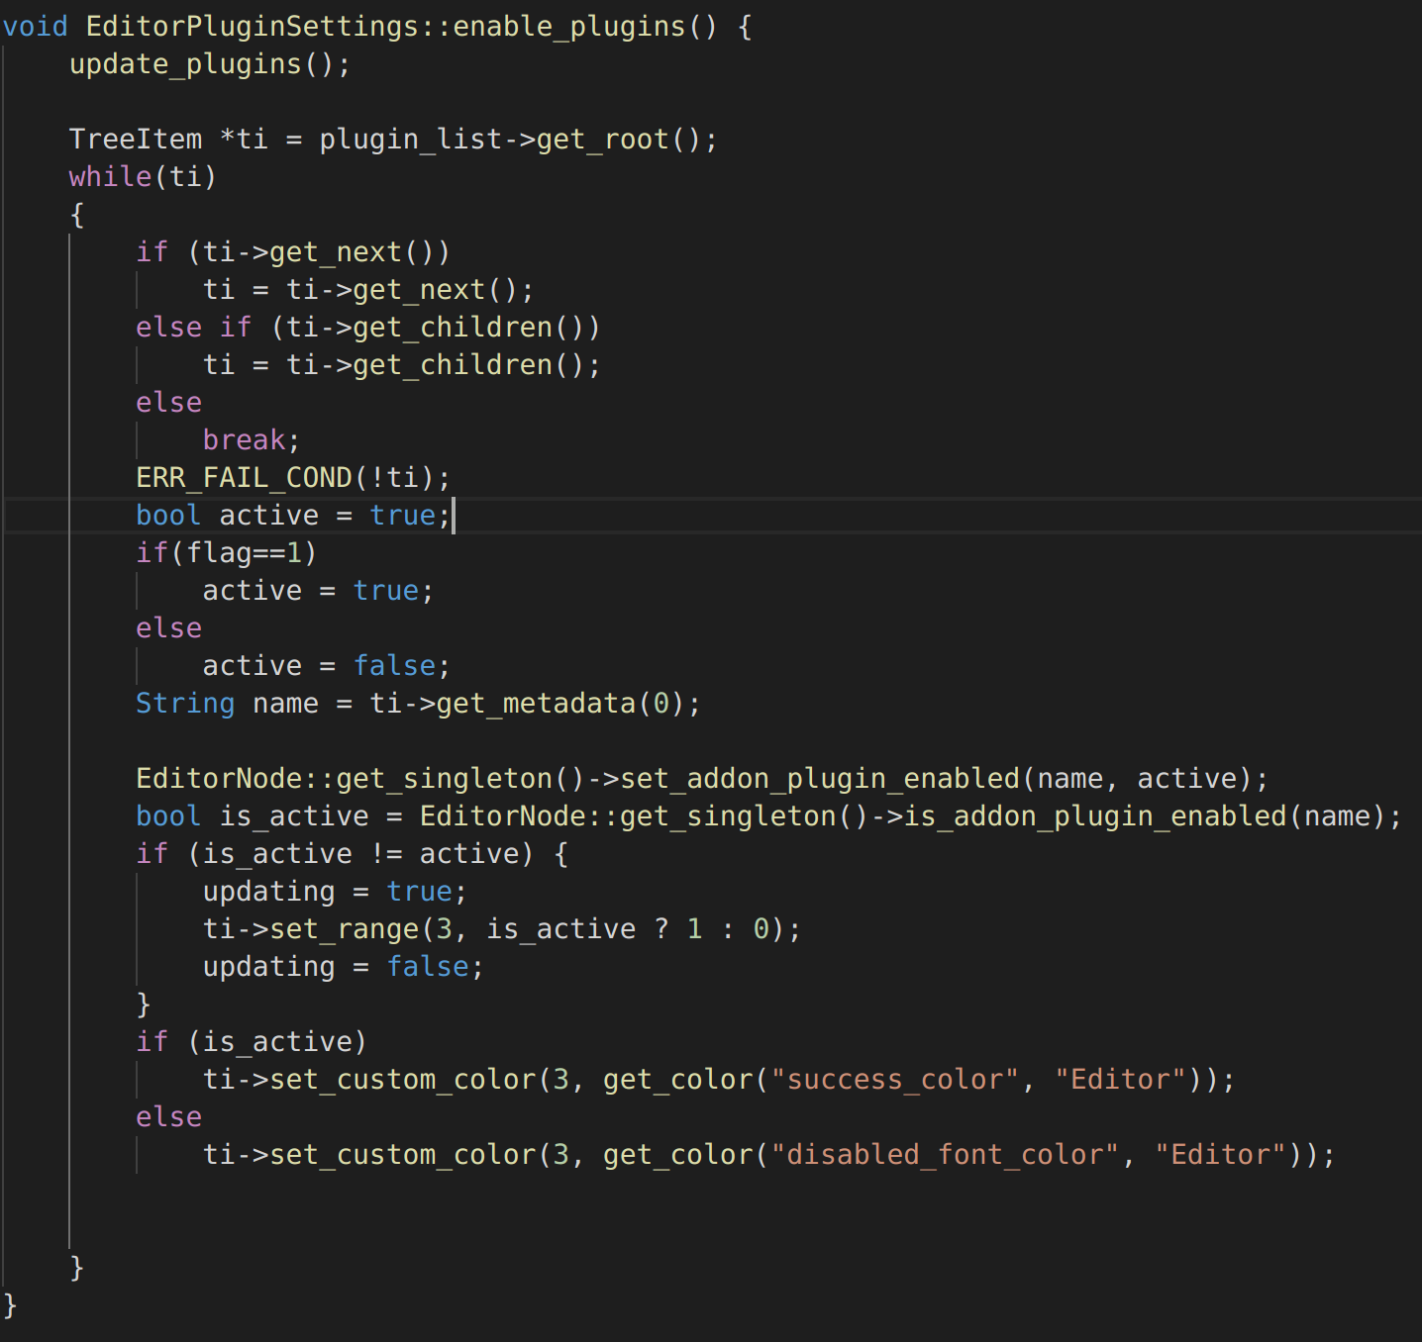

*Fig 4. Screenshot of added code to editor/editor_plugin_settings.cpp from line 49*

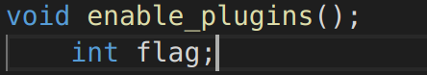

*Fig 5. Screenshot of added code to editor/editor_plugin_settings.h from line 65*

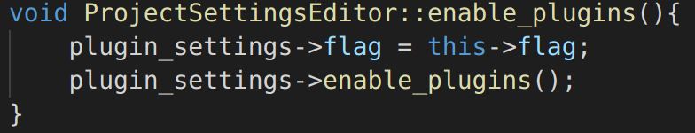

*Fig 6. Screenshot of added code to editor/project_settings_editor.cpp from line 812*

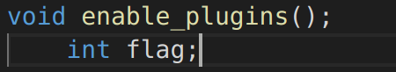

*Fig 7. Screenshot of added code to editor/project_settings_editor.h from line 190*